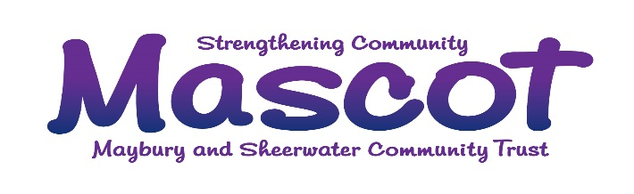
Mascot Hub, 43 Dartmouth Avenue, Sheerwater, Woking, Surrey, GU21 5PE
hub@mascotwoking.org.uk www.mascotwoking.org.uk 01932 988160
Registered Charity No. 1145217

DATA PRIVACY NOTICE

1. Your personal data – what is it?
Personal data relates to a living individual who can be identified from that data. Identification can be by the information alone or in conjunction with any other information in the data controller’s possession or likely to come into such possession. The processing of personal data is governed by the General Data Protection Regulation (the “GDPR”).

2. Who are we?
The Maybury and Sheerwater Community Trust (Mascot) is the data controller (contact details above). This means it decides how your personal data is processed and for what purposes.

3. How do we process your personal data?
Mascot complies with its obligations under the “GDPR” by keeping personal data up to date; by storing and destroying it securely; by not collecting or retaining excessive amounts of data; by protecting personal data from loss, misuse, unauthorised access and disclosure and by ensuring that appropriate technical measures are in place to protect personal data.

We use your personal data for the following purposes: -
- To enable us to provide a voluntary service for the benefit of the public in the Maybury and Sheerwater area and environs. Our work does also extend to other parts of the Woking Borough.
- To administer activity records, visitor lists and agency contacts in connection with our work;
- To fundraise and promote the interests of the charity;
- To manage our employees and volunteers;
- To maintain our own accounts and records (including the processing of gift aid applications and donations);
- To inform you of news, events, activities and services run by Mascot.

4. What is the legal basis for processing your personal data?
We can only hold data lawfully and the following are the bases as stated by GDPR: -
- Legitimate interest – where you have expressed an interest in taking part in activities run by Mascot or receiving assistance, you have expressed a wish to volunteer or want to be kept up to date with news and events or are partnering to serve the local community.
- Legal obligation – relating to gift aid where we are required by law to hold such information;
- Contract – in the case of employees and Mascot property hirers;
- Consent – for people wishing to give feedback used for internal monitoring or fundraising.

5. Sharing your personal data
Your personal data will be treated as strictly confidential and will only be shared with other agencies in order to carry out a service. We will only share your data with third parties outside of Mascot with your consent.

6. How long do we keep your personal data?
Specifically, we retain gift aid declarations and associated paperwork for up to 6 years after the calendar year to which they relate. We keep your other personal data for no longer than is reasonably necessary and we only retain your data for the purposes detailed in section 3 while you have a connection with Mascot (i.e. you are a client, you are a volunteer, you are an employee, have expressed interest in participating in Mascot activities either on a one-off occasion or regularly or while you are hiring Mascot property).

7. Your rights and your personal data
Unless subject to an exemption under the GDPR, you have the following rights with respect to your personal data: -
- The right to request a copy of your personal data which Mascot holds about you;
- The right to request that Mascot corrects any personal data if it is found to be inaccurate or out of date;
- The right to request your personal data is erased where it is no longer necessary for the Mascot to retain such data;
- The right to withdraw your consent to the processing at any time;
- The right to data portability, i.e. the right to request that Mascot provide the data subject with his/her personal data and where possible, to transmit that data directly to another data controller.
- The right, where there is a dispute in relation to the accuracy or processing of your personal data, to request a restriction is placed on further processing;
- The right to object to the processing of personal data.
- The right to lodge a complaint with the Information Commissioners Office.

8. Further processing
If we wish to use your personal data for a new purpose, not covered by this Data Protection Notice, then we will provide you with a new notice explaining this new use prior to commencing the processing and setting out the relevant purposes and processing conditions. Where and whenever necessary, we will seek your prior consent to the new processing.

9. Contact Details

To exercise all relevant rights, queries of complaints please in the first instance contact the Mascot Management Committee by calling 01932 988160 or emailing hub@mascotwoking.org.uk

You can contact the Information Commissioners Office on 0303 123 1113 or via their website www.ico.org.uk or at the Information Commissioner's Office, Wycliffe House, Water Lane, Wilmslow, Cheshire. SK9 5AF.

